DC DRINKING

Nathan Andersen

AS92005

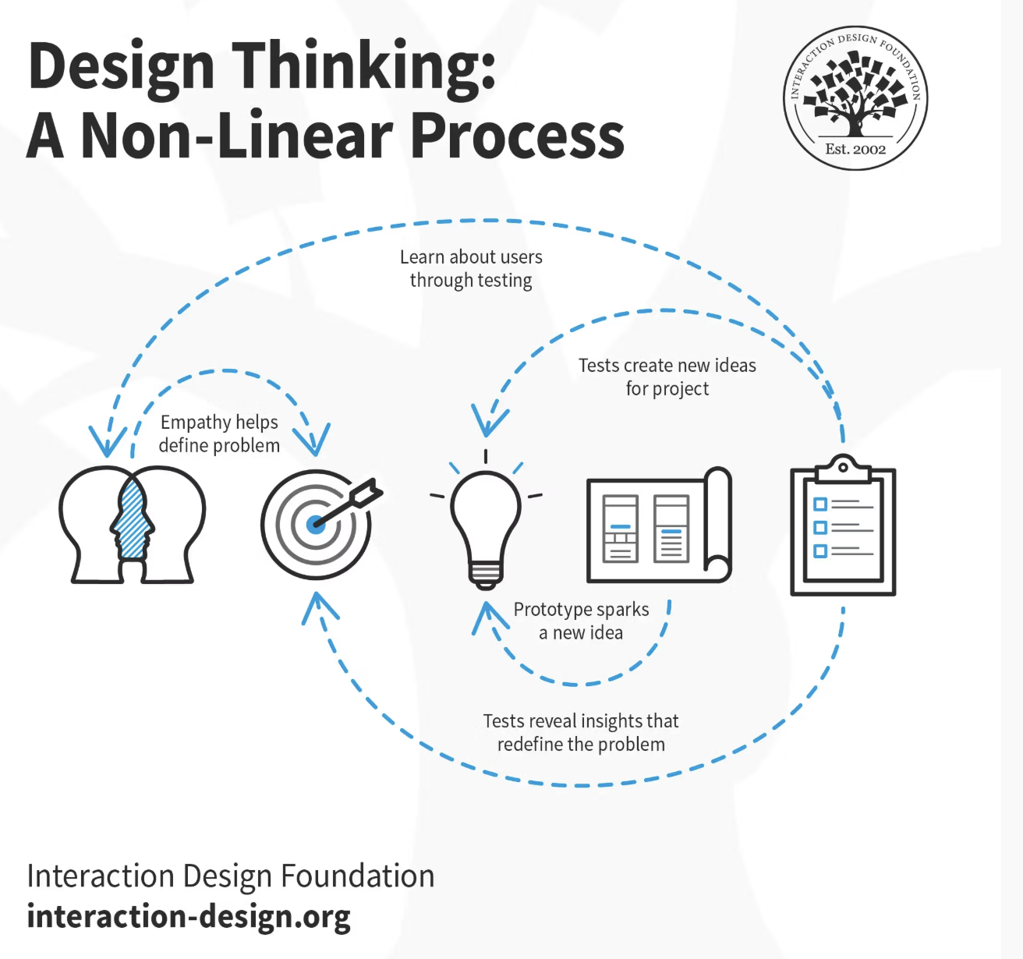

# Empathizing – The Challenge or Opportunity that Inspired My Outcome

# Defining – My Brief and Specifications

# Ideating – My Prototyping

# Testing – Feedback

## Testing and Evaluation of Prototype

*Two User Tests*

## Testing and Evaluation of Early Iteration

*Two User Tests*

# Final Outcome and Evaluation

# Commentary on Conventions, Techniques and Tools

## Conventions

## Techniques

## Tools

# Commentary on Relevant Implications